Ravensbury Community School
Y1 Connected Curriculum Overview

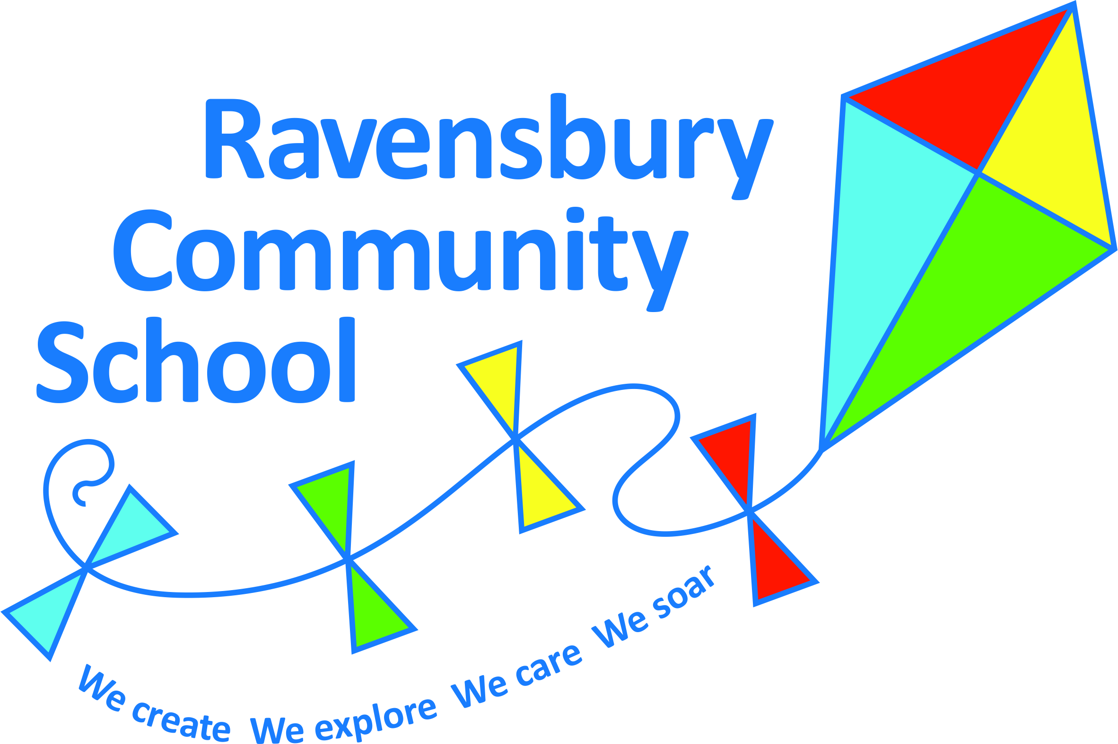

Year 1 | Key Texts – link to English | History | Geography | Art | Design Technology | Experience and Golden Question
Autumn 1  How is my world changing? | Supertato  Elliot midnight super hero  Senses poetry - cc | Changes in pupils’ own lives & family. developing awareness of the past, using common words and phrases relating to the passing of time.  Know where people and events they study fit within a chronological framework. Use a wide vocabulary of everyday historical terms. Understand some of the ways which we find out about the past and identify different ways in which it is represented.  Significant historical events and places in their own locality – opening of Etihad Stadium |  | Introduce sketchbooks  Painting:  Colour mixing challenge |  | Who are the most important people in your life?
Autumn 2  Could the three little pigs use a better material to build their house? | Three little pigs (2 weeks)  Stickman |  | Geographical skills and fieldwork  Make maps of events in stories – making own keys using own symbols.  Use compass directions (N S E W) and locational/directional language e.g. near and far, left and right to describe the locational features and routes on a map.  Devise a simple map.  Location Knowledge  Name/locate/identify characteristics of the 4 countries and capitals in UK. Use maps, atlases and globes to identify the ULK and its countries. |  | Structures  Design and make houses for the three little pigs.  Children to follow the Design Technology process of: Design, Make and evaluate.  Children to explore how they can build structures, making them stronger, stiffer and more stable. | If you could use any material, what would you build your house out of and why?
Spring 1  Is the Xbox more fun than your grandparent’s toys? | Lost in the toy museum  The magical toybo | Changes in events past and present – introduction to Victorian Toys which will then link to Year 2.  Way of life with a focus on toys: old and new toys/how children play |  | Drawing  Observational drawing of toys or puppets | Textiles  Punch and Judy puppets  Children to follow the Design Technology process of: Design, Make and evaluate.  To select and use a range of materials to join creatively to design and make a puppet. | Is your playtime more active than when your great-grandparents were children?
Spring 2  How do the wheels on the bus go around and round? | Naughty bus  Transport information text | Ask and answer questions about the past:  Transport  Significant events: International events beyond living memory  The first flight. |  |  | Mechanical systems  Children to follow the Design Technology process of: Design, Make and evaluate.  Children to explore and use mechanisms in their vehicles featuring wheels and axles. | Is our life better now that our transport has changed?
Summer 1  How does your garden grow? | The little gardener  flower information texts  recipes |  | Geographical skills & fieldwork, park mini beast hunt.  Study area around school  Human & Physical geography  Identify seasonal and daily weather patterns in the UK and in relation to the Equator (Kenya topic) |  | Nutrition  Children to follow the Design Technology process of: Design, Make and evaluate.  Use the basic principles of a healthy diet to prepare a salad | What do the plants in our gardens need in order to grow?
 |  |  | Use simple fieldwork and observational skills to study the geography of school and its grounds and the key human physical features of the surrounding environment. |  | from products which can be grown in school e.g. carrots, cress, potatoes, green beans etc.
Summer 2  How would you get to the Maasai Mara? | Mama Panyas pancakes  Pretty Salma  Information text |  | Geographical skills and fieldwork  Study area around school and the Maasai Mara, look at similarities and differences.  Street view –Google maps.  Geographical skills and fieldwork  Use maps, atlases and globes to identify countries (Kenya) and the continent of Africa and the Equator.  Place Knowledge  Understand similarities and differences between Clayton, Manchester and the Maasai Mara, Kenya.  Study a small area in a non-European country (Maasai Mara – Kenya) | Textiles/Collage  Cultural study: Kamau Joseph (Kenyan Artist)  https://indigoarts.com/artists/kamau-cartoon-joseph  To develop a range of techniques using colour, pattern and texture. |  | Would you prefer to live in England or the Maasai Mara?

