Ravensbury Community School
Y3 Connected Curriculum Overview

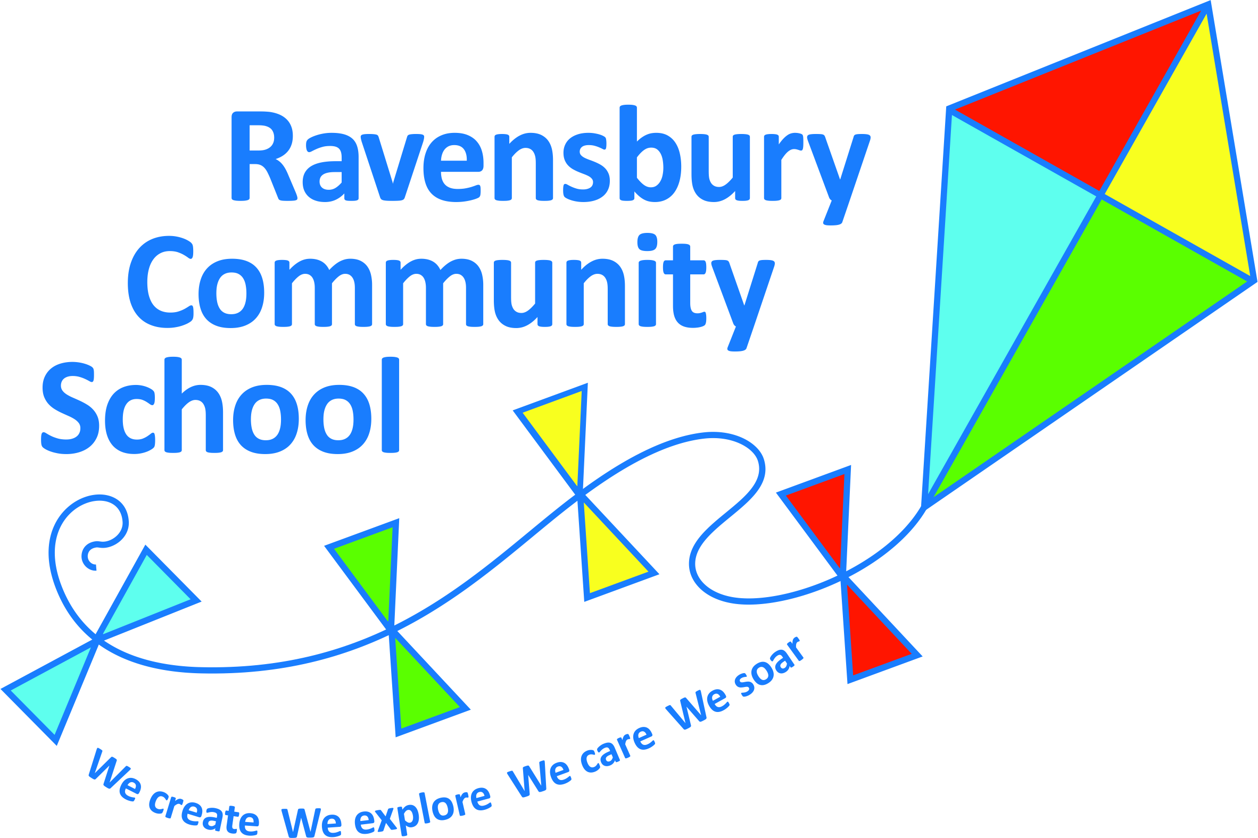
Year 3 | Key Texts – link to English | History | Geography | Art | Design Technology | Experience and Golden Question
Autumn 1  What was it like to live in Ancient Egypt? | Egyptian Cinderella  Ancient Egypt: Tales of  Gods and Pharaohs | World History: The achievements of an Early Civilization – where and when it appeared. Changes in social structure.  Ancient Egypt |  | 3D: Egyptian study  (Canopic jars)  To improve mastery of sculpture techniques.  To use sculpture to develop and share ideas |  | Would you like to have lived in Ancient Egypt and why?
Autumn 2  What is it like in the Amazon Basin? | Non- texts about Amazon Basin |  | Location knowledge:  The study of a region in South America – Amazon Basin.  To describe and understand key aspects of types of settlements and land use, economic activity including trade links and the distribution of natural resources.  Use maps, atlases, globes and digital mapping to locate countries and describe the features within the Amazon Basin. | Painting and Printing  Artists inspired by the Amazonian Biome – John Daly/Nixiwaka Project  https://www.edenproject.com/visit/whats-on/spirit-of-the-rainforest-art-project  To improve mastery of art and design techniques to improve painting |  | Is deforestation good or bad for the planet?
Spring 1  What lies beneath our feet? | Stone Age Boy  The Stone Age –Usborne/DK finds out | The Stone Age to the Iron age: Late Neolithic hunter-gatherers and early farmers (Skara Brae) |  |  | Structure: Stone Age Houses  Children to follow the Design Technology process of: Design, Make and evaluate.  Understand how to strengthen, stiffen and reinforce more complex structures.  Select from a range of tools and equipment to finish your product  Explain how and why my design fits with the needs of a stone age man. | Why do you think woolly mammoths became extinct?
Spring 2  Why were the Romans so powerful? | Famous People Famous Lives: Boudicca  Selection of non-fiction texts | UK history: Roman Britain in depth – the British Resistance (Boudica) and the impact of Roman Britain on life today. |  | Collage: Mosaic art  To improve their mastery of art and design techniques in colour, pattern, line and shape through mosaics. |  | If you were a Roman would you enjoy watching Gladiators fight?
Summer 1  How did that blossom become an apple? | The Great Kapok Tree |  | Place Knowledge: Mountains  Identify the names and locations of mountain ranges in the UK and identify key physical features of a mountain range such as summit, valley, tree line, outcrop, tarn, quarry, peak, base.  What is a typical mountain biome? |  | Nutrition  Use research and develop design criteria to inform the design of an appealing sandwich that is aimed at a particular group e.g. vegetarian, halal, vegan diets etc. | Should we give food to food banks?
Summer 2  What can we see in Blackpool? | Seaside poetry  Non-fiction texts |  | Study the human and physical geography of a region of the United Kingdom (coastal study of Blackpool & the Fylde Coast).  To name and locate the town of Blackpool on maps, atlases and in digital mapping. Look closely at the key topological features of a coast.  Observe, measure and record the human and physical features of the coastline. | Draw  Local artist focus  Lowry  To learn about great artists in history and make links to their own work.  ‘At the Seaside’ painting | Electrical systems: Designing and making a torch  Understand and use series circuits, bulbs and switches.  Apply understanding of computing to program and monitor their products.  (Lego We Do Kits) | If you had a picnic in Blackpool, why shouldn’t you leave your rubbish on the beach?

