Ravensbury Community School
Health and Safety Risk Assessment – Extreme Heat

School | Ravensbury Community School | Assessment No.

Subject of Assessment |  | Ravensbury Community School is a primary school for children aged 3-11 years
Assessed by | Nicola Richardson |  | Date | 18.07.2022 |  | Review date
Details of workplace/activity | Pupils and employees partaking in school activities within the school premises, including general classroom activities, dining, break-times, playgrounds, pick-up and drop off (where applicable), First aid and external visitors to the school. |  |  |  | Persons Affected  (Who may be harmed)
 |  |  |  |  | Students, Employees, Volunteers, Contractors and Visitors.

Assess the Level of Risk
In this risk assessment the level of risk is expressed qualitatively as Low, Medium, High or Very High. Underlying these descriptors of risk is a probabilistic model which factors the likelihood of an accident or event against the severity of harm that may occur. The risk rating, calculated as likelihood x severity, maps into the qualitative terms used as follows:

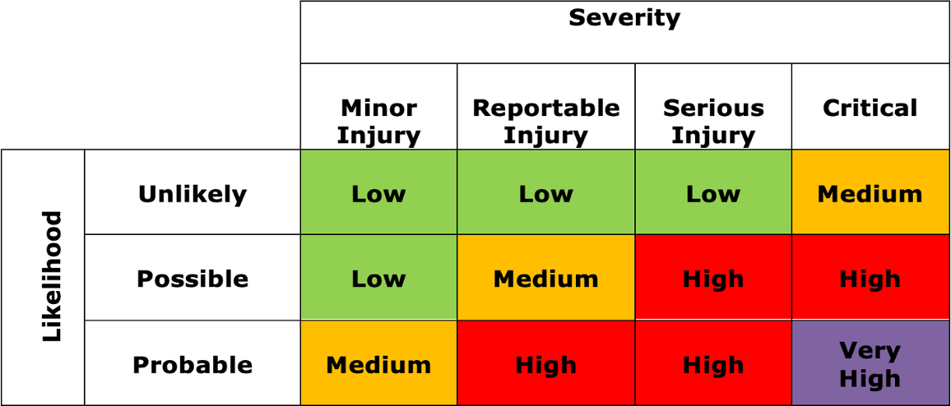

Hazards and Risks |  | Control Measures | Risk Level (Very High, High, Medium, Low) | Further Actions  - /X  (If ✓See Actions)
1. | Heat stress  Children suffering from heat stress may become irritable and experience discomfort. This can be exacerbated by physical activity and if not addressed can lead to heat exhaustion or heatstroke.  Heat exhaustion  Symptoms of heat exhaustion can include one or several of the below:  - Tiredness  - Dizziness  - Headache  - Nausea  - Vomiting  - Hot, dry, or red skin  - Confusion | Protection of Students from Heat-Related Illness  During periods of high temperature, the following steps should be taken:  - Share the signs of heat stress, heat stroke, and heat exhaustion with all staff, so they are all aware and are on the lookout for anyone, themselves included, that may be suffering  - Ensure the first aiders are on high alert and are ready to respond quickly to any staff member, or student presenting with any of the symptoms  - Using the guidance document for advice, consider the arrangements you have in place and adjust where necessary  - Update your risk assessments to show you can sufficiently evidence the adjustments made to an activity where there may be an increased risk from the high temperatures or exposure to the sun  - Review the pupil and Staff Medical Needs – send out reminders regarding sun hats and sun cream to parents  - Water coolers available in school for access to water for pupils and staff | High

Hazards and Risks |  | Control Measures | Risk Level (Very High, High, Medium, Low) | Further Actions  - /X  (If ✓See Actions)
Protection Outside:

- Children should not take part in vigorous physical activity on very hot days, such as when temperatures are in excess of 30°C.
- Encourage children playing outdoors to stay in the shade as much as possible
- If the temperature exceeds 30°C then arrangements for pupils not to go out during lunchtime and playtimes
- Provide children with plenty of water and encourage them to drink more than usual when conditions are hot.

Protection Indoors:

- Open windows / outside doors as early as possible in the morning before children arrive
- Ensure skylights are opened as early as possible
- Switch off all electrical lighting to a minimum
- If necessary, consider rearranging school start, finish and play times to avoid teaching during very hot conditions

Hazards and Risks |  | Control Measures | Risk Level (Very High, High, Medium, Low) | Further Actions  - /X  (If ✓See Actions)
- Almost close windows when the outdoor air becomes warmer than the air indoors – this should help keep the heat out while allowing adequate ventilation
- close indoor blinds, but do not let them block window ventilation
- Switch off all electrical equipment, including computers, monitors, and printers when not in use – equipment should not be left in ‘standby mode’ as this generates heat

- If possible, use those classrooms or other spaces which are less likely to overheat (community room), and adjust the layout of teaching spaces to avoid direct sunlight on children
- Oscillating mechanical fans can be used to increase air movement if temperatures are below 35°C – at temperatures above 35°C fans may not prevent heat-related illness and may worsen dehydration

Hazards and Risks |  | Control Measures | Risk Level (Very High, High, Medium, Low) | Further Actions  - /X  (If ✓See Actions)
2. | Heatstroke  Heatstroke is a medical emergency and can develop if heat stress or heat exhaustion are left untreated, but it can also occur suddenly and without warning. Symptoms include:  - high body temperature – a temperature of or above 40°C (104°F) is a major sign of heatstroke  - red, hot skin and sweating that then suddenly stops  - fast heartbeat  - fast shallow breathing  - confusion/lack of co-ordination  - fits  - loss of consciousness | If you believe a pupil is suffering from heatstroke  the following action should be taken to reduce their body temperature:  - Move the child to as cool a room as possible and encourage them to drink cool water (such as water from a cold tap).  - Cool the child as rapidly as possible, using whatever methods you can. For example, sponge or spray the child with cool (25 to 30°C) water – if available, place cold packs around the neck and armpits, or wrap the child in a cool, wet sheet and assist cooling with a fan.  - Dial 999 to request an ambulance if the person doesn’t respond to the above treatment within 30 minutes.  - Please note, if a student loses consciousness or has a fit place the student in the recovery position and immediately call 999. | High

More information is available at the following links:
- Heatwave Plan for England – UK Health Security Agency’s heatwave plan for England
- Looking After Children and Those in Early Years Settings During Heatwaves: For Teachers and Professionals – DfE’s guidance for schools in heatwaves
- Met Office Warnings – UK weather warnings and advice from the Met Office.

